AIM: TO Desgin a visitor counting system with the help of LDR for a hall

APPARATUS: Andruino,UNO, Resistor, photoresistor, Connecting Wires.

CIRCUIT DIAGRAM:

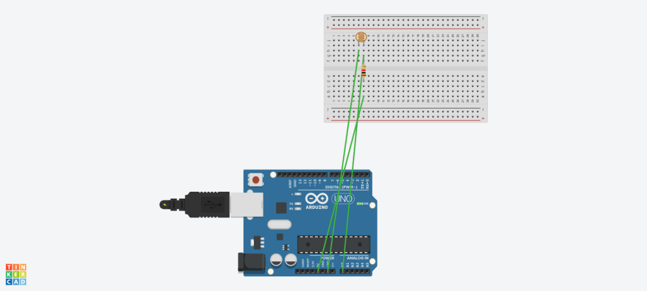

SOURCE CODE :

void setup()

{

pinMode(13, OUTPUT);

Serial.begin(9600);

}

void loop()

{

int d=analogRead(A0);

int count=0;

Serial.print(d); delay(1000);

printf("For entry doors");

if(d>350)

{

count++;

printf("%d",count);

}

else

printf("For exit door");

{

count++;

printf("%d",count);

}

}

PROBLEM FACING :

1. I have to face problem while I was dealing with the coding part
2. The wires connecteion was not correct at first